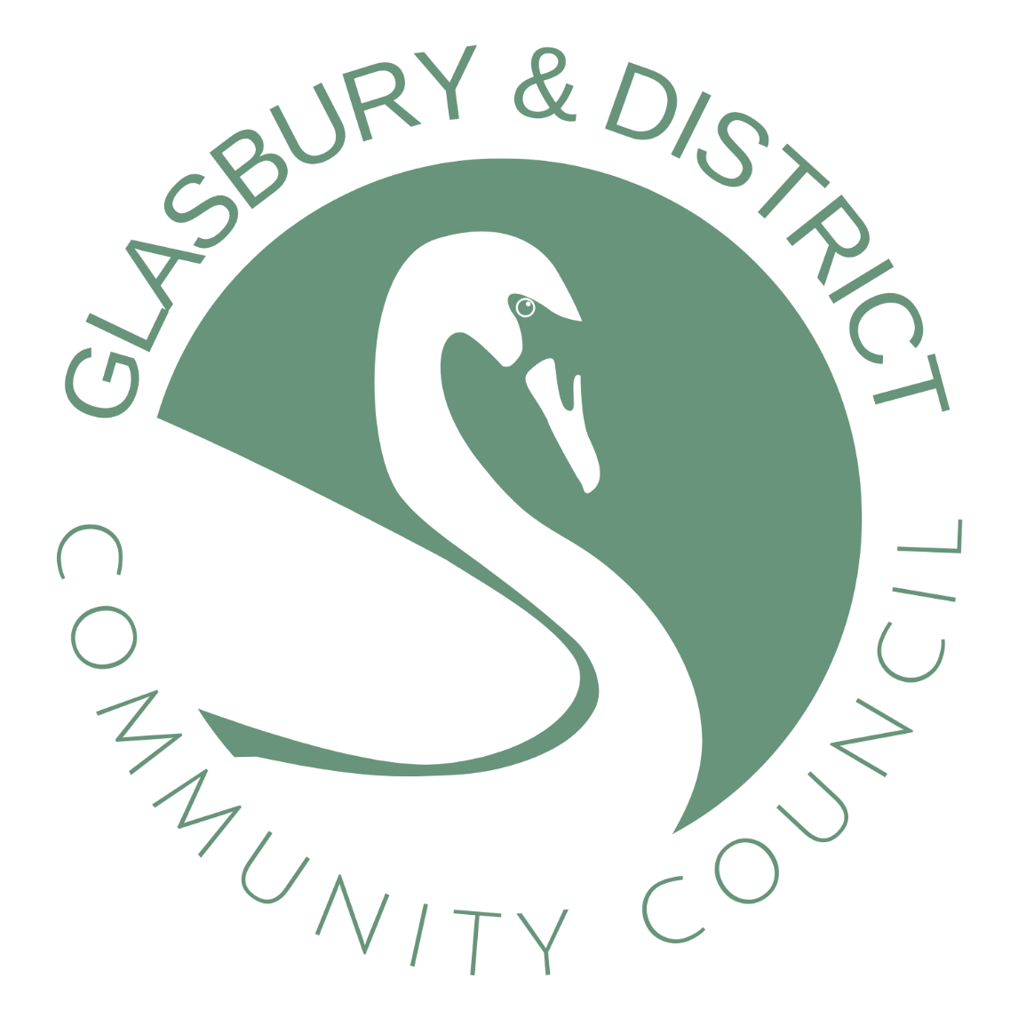

**TRAINING PLAN**

**As at 20 May 25**

**G&DCC TRAINING PLAN**

(For the purposes of this document G&DCC has vacancies for ten councillors (including Chair and Vice-Chair) and one member of staff (Clerk)).

**Introduction**

1. The Council has a statutory duty under Section 67 of the Local Government and Elections (Wales) Act 2021 to make a plan setting out what it proposes to do to address the training needs of its councillors and staff.

2. The purpose of the training plan is designed to ensure that collectively, councillors and staff, possess the knowledge and awareness needed for the Council to operate effectively. It is not necessary for all councillors and staff to have received the same training and develop the same expertise.

3. A new training plan will be put in place after each ordinary election of community councillors to reflect training needs resulting from the election of new councillors. The plan will be reviewed annually to ensure it is up to date and relevant.

**Aim**

4. The Council’s training aims are:

a. To improve the understanding of its members of their role as a community councillor, the powers available to the Council and how best to utilise the resources available to the Council for the betterment of the community.

b. To provide the necessary training to its staff to ensure that they are able to undertake their respective roles.

c. To ensure an acceptable level of succession planning in order to:

a. Ensure the Council can operate effectively following elections and potential changes to the Council membership.

b. Ensure the Council can continue to operate during times where staff may be unavailable (eg holidays, sickness staff turnover).

**Staff Training**

5. As follows:

|  |  |
| --- | --- |
| Induction Training | As required |
| staff appraisals to develop training | Annually |
| The Clerk will undertake the following, for which the  Council will provide financial support:  1. ILCA - Introduction to Local Council Administration  2. FILCA (Wales) - Financial Introduction to Local Council Administration | Year 1  Year 1 |
| The Clerk will identify and complete further personal development training in conjunction with:  1. SLCC  2. One Voice Wales  3. PAVO | As required |

**Councillors**

6. As follows:

|  |  |
| --- | --- |
| All Councillors are provided with an Induction Pack as soon as practicable after the local elections, or following co-option. | On appointment |
| All Councillors shall undertake training in the Code of Conduct within 6 months of the delivery of their declaration of acceptance of office. | On appointment |
| All Councillors will read the following publications:  The Good Councillors Guide  Governance and Accountability – A Practitioners Guide | On appointment |
| Complete a skills audit to identify training needs, and complete training modules provided by One Voice Wales. | Yearly in June |

**Training Modules**

7. One Voice Wales has developed a training scheme for community councils which is available across Wales. The packages have been designed on a modular basis with units that can be delivered in 2.5-hour evening sessions, this being the preferred format of the majority of councils. The modules cover:

The Council

The Councillor

The Council as an Employer

Understanding the Law

Council Meetings

Local Government Finance

Health & Safety

Introduction to Community Engagement

Code of Conduct

Chairing Skills

Community Emergency Planning

Community/Place Planning

Community Engagement Part II

Equality & Diversity

Information Management

Use of IT, Websites & Social Media

Making Effective Grant Applications

Managing your staff

Devolution of Services

Wellbeing of Future Generations Act 2016 / Sustainability

Local Government Finance (Advanced)

Mediation and Conciliation

8. Councillors will determine which modules they wish to undertake as part of their annual skills audit. Once confirmed by the Chair these will be booked through One Voice Wales on a repayment basis, with expenses claim submitted to the Clerk.

**Funding**

9. One Voice Wales will provide two free places on each of the following modules: Council as an Employer, Understanding Local Government Finance (Basic), Understanding Local Government Finance (Advanced), Understanding the Law, and Code of Conduct.

10. G&DCC makes financial provision for the cost of training as part of its annual budget. In addition, the Welsh Government makes available an annual bursary of £100 towards the cost of training. The current annual training budget is £200; this figure will be reviewed annually as part of budget development.

**Training Plans**

11. Individual training plans are attached.

**G&DCC TRAINING PLAN**

**Name**: Barbara Lloyd **Role**: Chair

|  |  |  |  |  |
| --- | --- | --- | --- | --- |
| **Event** | **Completed** | **2023** | **2024** | **2025** |
| Issued Good Councillor’s Guide | Jun 22 | May | May | May |
| Issued Local Government Code of Conduct, and Welsh Ombudsman Guidance | May 22 | May | May | May |
| Issued One Voice Wales Online training link, including Code of Conduct | May 22 | May | May | May |
| Issued Governance and Accountability – A Practitioners Guide (Wales) | Sep 22 | May | May | May |
| All Wales Basic Safeguarding | Dec 21 |  |  |  |
| Code of Conduct | June 19 |  |  |  |
| New Councillor Induction | Sept 18 |  |  |  |
| Advanced Local Government Finance - Module 21 |  | Apr |  |  |

**G&DCC TRAINING PLAN**

**Name**: Dave Briggs **Role**: Cllr

|  |  |  |  |  |
| --- | --- | --- | --- | --- |
| **Event** | **Completed** | **2023** | **2024** | **2025** |
| Issued Good Councillor’s Guide | Jun 22 | May | May | May |
| Issued Local Government Code of Conduct, and Welsh Ombudsman Guidance | May 22 | May | May | May |
| Issued One Voice Wales Online training link, including Code of Conduct | May 22 | May | May | May |
| Issued Governance and Accountability – A Practitioners Guide (Wales) | Sep 22 | May | May | May |
| The Councillor - Module 2 |  | Mar |  |  |
|  |  |  |  |  |

**G&DCC TRAINING PLAN**

**Name**: Jowi Hewitt **Role**: Cllr

|  |  |  |  |  |
| --- | --- | --- | --- | --- |
| **Event** | **Completed** | **2023** | **2024** | **2025** |
| Issued Good Councillor’s Guide |  | Jan | May | May |
| Issued Local Government Code of Conduct, and Welsh Ombudsman Guidance |  | Jan | May | May |
| Issued One Voice Wales Online training link, including Code of Conduct |  | Jan | May | May |
| Issued Governance and Accountability – A Practitioners Guide (Wales) |  | Jan | May | May |
| New Councillor Induction (OVW) |  |  |  | Feb |
|  |  |  |  |  |

**G&DCC TRAINING PLAN**

**Name**: Jan Gardiner **Role**: Vice-Chair

|  |  |  |  |  |
| --- | --- | --- | --- | --- |
| **Event** | **Completed** | **2023** | **2024** | **2025** |
| Issued Good Councillor’s Guide | Jun 22 | May | May | May |
| Issued Local Government Code of Conduct, and Welsh Ombudsman Guidance | May 22 | May | May | May |
| Issued One Voice Wales Online training link, including Code of Conduct | May 22 | May | May | May |
| Issued Governance and Accountability – A Practitioners Guide (Wales) | Sep 22 | May | May | May |
| Local Government Finance - Module 6 |  | Mar |  |  |
|  |  |  |  |  |

**G&DCC TRAINING PLAN**

**Name**: Paul Griffiths **Role**: Cllr

|  |  |  |  |  |
| --- | --- | --- | --- | --- |
| **Event** | **Completed** | **2023** | **2024** | **2025** |
| Issued Good Councillor’s Guide | Jun 22 | May | May | May |
| Issued Local Government Code of Conduct, and Welsh Ombudsman Guidance | May 22 | May | May | May |
| Issued One Voice Wales Online training link, including Code of Conduct | May 22 | May | May | May |
| Issued Governance and Accountability – A Practitioners Guide (Wales) | Sep 22 | May | May | May |
|  |  |  |  |  |
|  |  |  |  |  |

**G&DCC TRAINING PLAN**

**Name**: Gus Powell **Role**: Clerk

|  |  |  |  |  |
| --- | --- | --- | --- | --- |
| **Event** | **Completed** | **2023** | **2024** | **2025** |
| Issued Good Councillor’s Guide | Jun 22 |  |  |  |
| Issued Local Government Code of Conduct, and Welsh Ombudsman Guidance | May 22 |  |  |  |
| Issued One Voice Wales Online training link, including Code of Conduct | May 22 |  |  |  |
| Issued Governance and Accountability – A Practitioners Guide (Wales) | Sep 22 |  |  |  |
| ILCA | 22 Mar 22 |  |  |  |
| FILCA (Wales) |  | 23 Jan 23 |  |  |
| CILCA | N/A |  |  |  |
|  |  |  |  |  |
|  |  |  |  |  |